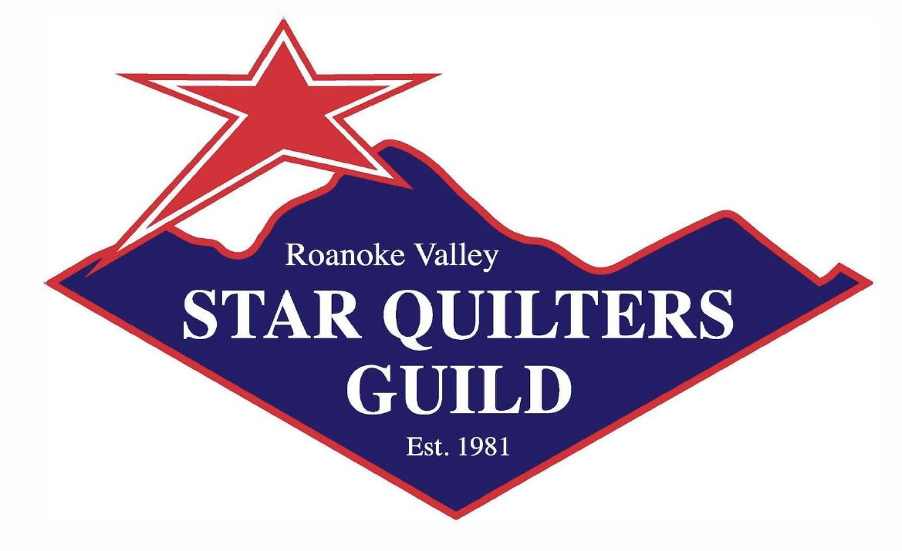
April 2022 Newsletter
Star Quilters Guild of Roanoke, Virginia,
and the surrounding area of the
beautiful Blue Ridge Mountains
http://starquilters.org/

Join us at Christ Lutheran Church, 2011 Brandon Avenue SW, Roanoke on Monday, April 4, at 6:30 PM for a Yard Sale
Our April program will be an indoor yard sale. The church will open about 5:00 pm for sellers to set up their tables. Selling will start at 6:30 for guild members and visitors. There will be no Ways & Means table, and no early bird sales.
Bring a tote bag, large and small bills, and maybe a checkbook to make your shopping easier. (You’ll be paying each vendor separately.)
Invite your friends – admission is free, and they might buy you something!

A Message from the Guild President
Our Spring Social is a chance to sit and talk with other guild members while eating a delicious meal. Give it a try – I think you’ll enjoy it!
At that meeting, we’ll be collecting pillowcases for Ryan’s Case for Smiles. Please make one (or some) if you can. See page 2 for more information.
New officers will take office at the May Social. They are President Dawn Schaben, Vice President Sue Berry, Treasurer Becky Foster, and Secretary Claire Hightower.
I’m looking for new committee members, too … a newsletter editor, a historian, and program committee members. Please let me know if you are interested.
I would like to say a very special thank you to Laura Perry. Laura started as the newsletter editor in March 2015. She resigned in April 2020 and Jill Moody became editor. Laura returned to the editor position in August 2021. She has produced 71 newsletters for us. I think that record is going to stand for a while. This newsletter will be Laura’s last newsletter for the guild. I know you will join me in wishing Laura all the best in all her future endeavors!
Kristin Farwig also deserves a special thank you for her service to the guild. Kristin has served the guild as historian with her wonderful talent behind the camera. She has also been working on the webpage and helping with technology for the past two years plus. While we will miss Kristin’s wonderful pictures of guild events, we can look forward to seeing more of her future creations at Show and Tell. Please thank Kristin for her service to the guild!
I am grateful to all the volunteers who do the work of the guild.
~ Dawn Schaben, President
page 1

Quilts for Ukraine
Needed by Friday, April 22nd
Pastor Dave Skole of Christ Lutheran Church (where the guild
meets) is collecting quilts to send to Ukraine, which we all know is
ravaged by war. If you have any quilts that you would like to donate to this cause, please contact me, Sue Berry. (My email address and phone number are in your membership directory.) I will be receiving the quilts on behalf of the church.
Pastor Dave and I are hoping some of you have quilts that you have made that your family has no interest in owning. Or any quilt for which you would like a home where it will be needed and appreciated! But we need them NOW.
I need to have the quilts by Friday, April 22nd.
Thank you for any quilts that you donate.
~ Sue Berry

Another group is collecting in Dade City, Florida, and Greenville, South Carolina:
https://blog.quiltedtwins.com/new-blog/2022/march-quilt-drive-now

Ryan’s Case for Smiles
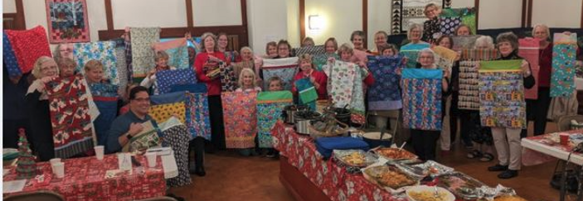

In December, we collected 66 pillowcases for hospitalized children and teens.
Let’s see if we can collect that many in May!
At our May meeting, we will be collecting pillowcases to donate to the local chapter of Ryan’s Case for Smiles. They will wash and iron them and deliver them to children (infants to age 18) in local hospitals.
If you can, please choose a cheerful fabric and make a pillowcase that will bring a smile to the face of a child who is having a hard time.
There are videos and instructions online, including directions posted at https://starquilters.org/2022/03/31/making-a-pillowcase-for-ryans-smiles/

Read about the group here:
https://caseforsmiles.org/

page 2
Guild Officers and Committees
Officers
Dawn Schaben, President
Ann Ware, Vice President
Claire Hightower, Secretary
Sue Berry, Treasurer
Committees
Comfort Quilts - Judy Bradley and Ethel Simmons
Historian - Kristin Farwig
Hospitality - Gisela O'Connor, Judy McWhorter, Karen Lubeck, and Carolyn Zaleski
Library - Kathy Wickham and Betty Ann Tyree
Membership - Jennifer Adams and Donna Conner
Newsletter - Laura Perry
Program - Richard DeHart, Sue Berry, Susan Dewberry, Tonya Harmon,
Donna Kittleson, and Angela Miller
Publicity - Sarah Baumgardner
Social Media - Sarah Baumgardner, Richard DeHart, Kristin Farwig
Special Events - Cathy Russell
Sunshine - Sue Thurston
Ways & Means - Donna Bohon and Cathy Henderson
Their telephone numbers and email addresses are in the Membership Directory.

Upcoming Programs
May program: Our Spring Social and Pillowcase Drive
Our meeting on May 2nd will be devoted to food, fun, and friends. Bring something for a big salad bar or tell Gisela if you’d like to bring a dessert instead. We will have Show & Tell, so bring your lastest creations to show, too.
We are going to collect pillowcases for donation at the Spring Social, too. Fire up your sewing machine and use that great fabric from the April yard sale to make some pillowcases for Ryan Smiles. Make a sick kid happy!
June program: What to Do With Scraps
Ann Ware will be sharing with us her secrets for dealing with fabric scraps.


Our Guild Needs a Historian (Photographer) and a Newsletter Editor
Our guild works best when everybody helps.
Right now, we have a critical need for a historian
and an editor for the newsletter. We also need people
with ideas for programs. Please let Dawn Schaben
know if you are able to help.
Image from http://libraries.ne.gov/tekamah page 3
It’s Time for Membership Dues and Directory Photos
It’s about time to renew your guild membership. Your current membership will run out APRIL 30th!! We have some changes to the options this year for renewing your membership or joining the guild as a new member. We have made some changes to the Member Information form, so be sure to use a form with the new logo at the top.
Go to our website www.starquilters.org and under the ABOUT tab you will find MEMBERSHIP. You can click on the “Join our group or Renew your Membership” link or choose the "printable form" icon and print your form from the website.
Dues are $20.00. We accept cash or checks. We no longer are using Paypal. You may mail your information form with a $20 check made out to STAR QUILTERS GUILD to:
Star Quilters Guild - Attn: Membership - 5929 Brahma Road - Roanoke, VA 24018

The new membership form is on the last page of this newsletter. You can print it out to use. I will have extra copies at meetings.
With a new membership year comes a new MEMBERSHIP DIRECTORY, so if you have not had a new headshot photo taken yet, now is the time to do it. Sarah will be taking pictures again at the April meeting. Thank you, Sarah!
If you prefer, you can send a recent headshot of yourself to Jennifer Adams, 5929 Brahma Road, Roanoke, VA 24018. Attn: SQG.
~ Jennifer Adams and Donna Conner, Membership Committee

Financial Information for February 1-28, 2022
Truist Checking Account 1:
$ 10,011.41 Beginning balance
$ 10,449.56 Ending balance
$ 475.85 Income received
$ 37.70 Expenses paid
At the direction of the Star Quilters Guild Board, I have canceled our PayPal account. Payments to the guild in the future must be by check or cash.
The Truist bank second checking account, which was needed in conjunction with the PayPal account, will also be canceled.
Please call me if you have comments or questions.
~Sue Berry, Treasurer
Share a Ride!
Some of the people in our guild who would like to join us at our meetings are unable to drive alone at night. If you are one of them, let us know, or try reaching out to someone who lives nearby. (Check the membership directory for addresses.)
If you are able to drive yourself to a meeting, think about whether someone else might want to accompany you.
You can talk about quilting (or quilters!).
page 4

Quilt Show Committee
March 14th was the kickoff to start planning the 2023 Quilt Show. We will be meeting on 4th Tuesdays each month.
Our next meeting is scheduled for Tuesday, April 26th at 6:30. The location is Christ Lutheran Church (our regular guild meeting location).
The planning committee is open to all members of the Star Quilters Guild. Please join us in this exciting venture!
~ Ann Ware and Sue Berry, Quilt Show Chairs

To make our Quilt Show a success, YOU are NEEDED!

Our quilt show provides most of the funding for our guild. It pays for speakers at our programs and supports our comfort quilts program. It also lets us reach out to our community and share the fun of quilting.
In helping with the quilt show, you are helping your guild, your community, and yourself!

Many people will be needed to help once we are setting up and running the show at the Civic Center. Right now, here’s how you can help:
1. Design and sew ribbons to be awarded to the winning quilts.
2. Think about whether you have quilts suitable for display in the Bed Turning, a history of quilting in America that uses treasured quilts with real histories from guild members.
3. Start collecting quilt items (tools, patterns, fabric) you can donate for the door prize baskets, always a popular favorite. (Possibly baskets for vendors, too.)
4. Let the Quilt Show Committee know about people and companies that might buy an advertisement in our program. (Maybe your company? A place you shop? A neighbor’s firm?)
5. Help the Publicity coordinator to write and print information about the show, and distribute copies to area quilt shops. Let the Publicity coordinator know if you have friends in media who could help us advertise the show.
6. Help to make a big raffle quilt!
7. People who come to the show also SHOP at the show. The Vendor coordinator needs help in finding people who want to have booths at the show to sell things.
8. Come to meetings of the Quilt Show Committee. You may feel some of the excitement that the Little Rascals or Mickey Rooney felt in the old films when they'd say, "Hey, kids! Let's put on a show!"
page 5
Lake Quilters Guild Quilt Show - April 29-30
"Every Story Has a Quilt... Every Quilt Has a Story"

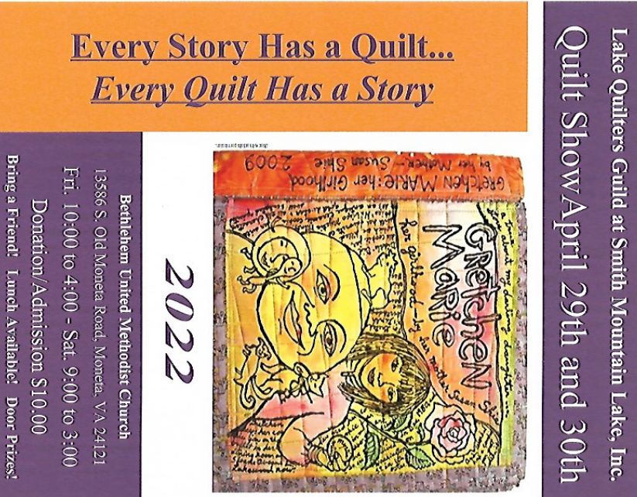
The Lake Quilters Guild at Smith Mountain Lake will hold its long-awaited quilt show at the Bethlehem United Methodist Church located at 13586 South Old Moneta Road, Moneta, VA. 2412 Show times will be Friday, April 29, 2022 from 10 am to 4 pm and Saturday April 30, 2022 from 9 am to 3 pm. Admission is $10.00 per person.
There will be approximately 200 hand-made quilts, wearables, bee displays, and stories about quilts and their quilt makers.
Viewers will be able to choose winners in each size category with a ballot for each attendee’s favorite quilt.
http://www.lakequilters.org/quiltshow/quiltshow.htm

April Quilt Shows a bit farther away
Maybe you can car-pool!
April 8-9 “Together Again” - Heart of the Triad Quilt Show in Winston-Salem, North Carolina - www.hottqg.com
April 9 - Lake Country Quilters Quilt Show at Clarksville Presbyterian Church in Clarksville (on the Roanoke River, but down near North Carolina) https://www.facebook.com/Clarksvilles-Lake-Country-Quilters-145582175972456/
April 9-10 Charlottesville Area Quilters Guild will have 180 quilts on display plus activities and door prizes - https://caqg.weebly.com/quilt-show-xvii.html
April 22-24 Northern Shenandoah Valley Quilt Show in Berryville, Virginia - sponsored by four quilt groups in that area. www.nsvquiltshow.com

Quilt Shops, Quilt Shows, and Fun Stops When You’re Traveling
Most of you are familiar with the publication called The Virginia Register, which Kathy Wickham brings to meetings for us every time it is published. It has ads for lots of quilt shops (and other fun places).
If you have travel plans, you can look up the issues for Connecticut, Massachusetts, and Rhode Island; Florida; Indiana; Maryland; New Jersey and Delaware; New York; Pennsylvania and West Virginia -- as well as the most recent one from Virginia -- here:
https://theregisterweb.com/download.html

page 6

Busy Hands
Join a group of members working on handwork projects on April 18th at Barnes and Noble, Tanglewood. Around 6:30 for 1½ hrs. Bring a new project or work-in-progress.

Comfort Quilts Delivered
Comfort Quilts gave 6 lap quilts to Friendship Manor for wheelchair patients. We also gave 12 quilts to Street Ransom, an agency that cares for victims of sexual exploitation and trafficking, ages 12 to 18 years old; 189 cases were reported in Virginia in the year 2020. Thank you to all who participated in making these comfort quilts.
Feel free to join Quiltessa sewing sessions at Our Lady of Nazareth Church each first Friday from 10 to 2. Or pick up a comfort quilt kit with fabric and batting at one of our meetings.
~ Judy Bradley, Comfort Quilts
Happy Birthday to our Guild Members Born in April
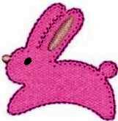
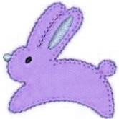
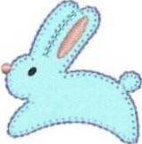
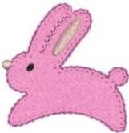
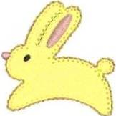
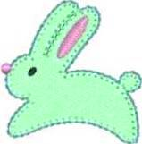

April 3 - Mary Lou April 20 - Loretta B
April 7 - Karen M April 22 - Lisa
April 9 - Diane April 27 - Richard
April 17 - Sandra April 28 – Sarah April 30 - Becky F

Best Wishes from Gisela O’Connor, Hospitality Chair, and your guild friends!

Stash Blast Coming to Christiansburg - Fabric Donations Needed
Paula Golden is collecting fabric donations for a Stash Blast at the Hampton Inn on Arbor Way in Christiansburg from 10 am to 2 pm on May 7, 2022. This is a fund-raiser for the Virginia Quilt Museum. Fabric will be on sale for $9.00 a pound.
Paula will collect and store donated fabric until the sale. Paulacgolden@comcast.net

A Wee Hint: Automatic Needle Threaders
If your sewing machine has an automatic needle threader, be sure you read the manual’s instructions on how to use it. With some machines, the needle needs to be in the highest position and the machine locked out, or it won’t work properly and may damage the needle threader. Also, don’t try to use the needle threader on the sewing machine for needles that are smaller than a size 80/12.
-- Kim Jamieson-Hirst page 7
Minutes of the Star Quilters Guild Meeting on March 7, 2022
We met (finally, no masks required!) at our usual meeting place, Christ Lutheran Church. President Dawn Schaben called our meeting to order at 7:00 PM.
Special Exhibit
Dawn asked Susan Kraterfield to explain the Starry Eyed Quilters display of the group’s Chinese Whispers quilts. For this project, one member created an art quilt with a theme in mind, then passed the quilt to the next person without an explanation of the theme, and that person created another quilt based on their interpretation of the quilt they were given, and passed only their quilt to the next person until all who wished to participate had a turn. The resulting quilts were beautiful.
Quilt Show Announcement
Our Guild will have a quilt show in 2023. Ann Ware and Sue Berry will co-chair the show committee, with the first meeting to be held March 14 at 6:30 at Christ Lutheran Church. All are invited to attend the meeting.
Business Meeting
Comfort Quilts: Twelve quilts were turned in at the March meeting, and 36 were turned in at the Friday workshop. Treasurer Sue Berry reported that Covenant Presbyterian Church’s Circle of Friendship has sent a donation of $200 to Comfort Quilts along with a nice note that she read to us.
Hospitality: Gisela announced the members who have birthdays in March.
Library: Kathy Wickham announced she expects to have new books in the library next month.
Membership: Jennifer Adams announced 61 members and 4 visitors were present. In the future, options for paying dues will include cash and check only.
Newsletter: The Newsletter Committee is looking for volunteers. Anyone interested in working on the newsletter should contact Laura Perry or Dawn.
Nominating Committee: Chair Cathy Russell announced the slate of officers for our upcoming election: President, Dawn Schaben; Vice President, Sue Berry; Treasurer, Becky Foster; and Secretary, Claire Hightower. The proposed slate of officers was approved by a show of hands.
Publicity: Sarah Baumgardner advised that the Roanoke Times is now charging a fee for formerly free meeting announcements in the newspaper, so we will no longer publish our meeting notices there.
Programs: Our April 4 meeting will be a Members’ Yard Sale held in our normal meeting space. The fee is $20 per table, or $30 for two tables, with the fee to be paid at the event, but please notify Sue Berry in advance so she knows how many tables are needed. The room will be available for setup starting at 5:00, with the sale to start at 7:00. Our May 2 meeting will be our Spring Social.
Special Events: Cathy Russell announced that thirty-one people have now signed up for the fall retreat. A road trip to the Lancaster, PA area is planned for April 7th
page 8
through April 10th. A sew-in at Fork Mtn Quilts is scheduled for February 23rd. There will possibly be a field trip to Covington in May. Wow, Cathy has been busy!
Ways and Means: The sale of donated items at our meeting totaled $223.85.
Treasurer: Sue Berry announced that our sale of items from Judy Bird’s estate has brought in $2800 so far, with additional items available for sale at our Yard Sale in April. Because of expense and confusion with using PayPal for payment of dues, dues must be paid by cash or check in the future.
Program
Program Chair Richard DeHart introduced our program, “I Wish I Had Known,” where several members offered advice based on their quilting experiences. So much useful information was presented that the Secretary may not have recorded it all. Ann Ware’s heartfelt hint was to just say no when someone asks you to finish a project they started if you really don’t want to do so. Dawn had hints for using rulers: use the ruler, not the mat, for measuring cuts; she is a fan of Marti Michell’s Corner Trimmer and other templates; the Folded Corner template is great for sewing border and binding strips; laminate the instruction sheets that come with templates for easier access; and use ruler spray and weights to keep rulers from slipping while you cut. Donna Kittelson offered a tip, presented by Sue Berry in Donna’s absence, on how to make eight half-square triangles at a time without paper piecing for the Scandi Row-by-Row quilt. Cathy Henderson advised that using a Kwik Klip to close safety pins used to baste quilts will prevent sore fingers and blood on your quilt. Linda Greene offered hints for hand quilting: thread the needle and wrap the end of the thread around the needle point a couple of times and then pull the needle through to create a knot; to keep the thread from pulling out of the needle’s eye while quilting, pass the point of the threaded needle through the thread three times near the unknotted end of the thread. Sue Berry advised that even though the batting maker says quilting may be spaced 8 or 10 inches apart, quilts made this way may not survive well if washed frequently. Cathy Fandel advocated, demonstrated, and had a handout of the Alex Anderson method of connecting quilt binding ends. Claire Hightower showed her first machine quilting project, a twin-sized quilt (too big for a first attempt) which she taped to the floor and pencil-marked for quilting (never again, especially twenty-some years later); on the positive side, she learned one absolutely must raise both the needle and the presser foot to thread the machine, and a walking foot can be used to quilt in gentle curves as for a cable border.
Closing. Several of our members treated us to a display of their recent quilts. The meeting adjourned at 8:55.
Respectfully submitted,
Claire Hightower, Secretary

---> Be sure to see Kristin’s photos of the Chinese Whispers Challenge quilts at
https://starquilters.org/2022/03/25/chinese-whispers-challenge-march-2022/
page 9
We’ve Started Row 3 of our Row-by-Row Quilt-Alongs
Featuring two free patterns and a fantastic prize to one lucky finisher!
If you’ve decided you want to join the RxR fun, it’s not too late! Send your request to join one or both groups to the group leaders:
Sue Berry (Scandi Row-by-Row): sueberry64@cox.net
Angie Miller (Modern Row-by-Row): angiesuemil@gmail.com
For more information, talk to them or see the February newsletter – online at https://starquilters.org/2022/02/02/star-quilters-guild-newsletter-february-2022/


Thank you for the kindness you have shown to me in the time I have been editor of the guild’s newsletter.
I am especially grateful to the people who have so faithfully provided me with material for it. Currently, those people include Claire Hightower, whose delightful meeting minutes not only make me chuckle but also remind me of things I have forgotten to add to the newsletter. And Ann Ware, Cathy Russell, Judy Bradley, Sue Berry, Jennifer Adams, Gisela O’Connor, and many others who keep me (and you) informed about what the guild is doing or planning to do. Over the years, there have been so many people who have made my job easier, and I am grateful for every one of them. I hope you know who you are and how much I thank you.
I resigned once before, and maybe you think I’ll change my mind again. It’s true that I’ll miss a job that puts me in the center of what our guild does. But I simply cannot do it anymore. There are too many things in my life that have had to wait while I used my sadly-limited energy to collect news, put out this newsletter, and send out emails as needed.
One of those reasons is indicated by this cartoon:


I sincerely hope that now I will have time to make quilts and clean my house. And to help a friend to finish a book that we started 3 years ago!
Good luck to the person or persons who become editor – it’s a fascinating, fulfilling job and (usually) lots of fun!
~ Laura Perry
page 10
Sewing Days at Fork Mountain Quilting
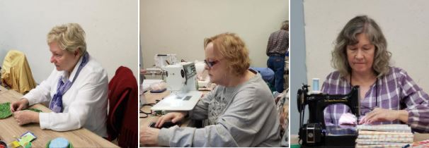

Despite the serious looks in these photos, we had a happy time sewing all day at Fork Mountain Quilting in March.
Our next date is Wednesday, April 20, 2022. Come join in the fun!
We will meet at Lowe’s on 220 and carpool to Rocky Mount. Please contact me if you would like to attend. -- Cathy Russell, Special Events

Road Trip to Lancaster, Pennsylvania

We are leaving on Thursday, April 7th for our trip to Lancaster, Pennsylvania. We will return April 10th.
You can learn what we’re seeing (and eating!) without joining facebook by going to
https://www.facebook.com/groups/114448361921935/
-- Cathy Russell, Special Events

Our Fall Retreat: September 14-18
Our Fall Retreat is September 14-18 at Smith Mountain Lake.
If you’re joining us, I need a deposit of $85.00 now. The total cost is $280 for 3¾ days of all-day sewing plus food and lodging. – Cathy Russell, Special Events

Starry Eyed Quilters
Are you too intimidated to come play with Starry Eyes?
Please don't be. Starry Eyes is all about support, sharing our knowledge, and getting inspired by each other.
Any time we do a challenge, there is NO competition. You create what *you* want. It can be leaning in to your normal wheel house in a new way, or something totally foreign to you; you choose. Whatever you make should please YOU. And if a particular project is not for you; no problem. Let that one go and do the next.
I get so much affirmation & help when I share Works in Progress with the group. And I've learned things I would never have attempted without their help.
If you are wistful when you see a Starry Eyes show n tell ... send me your email and give us a try.
~ Susan Kraterfield

Starry-Eyed: visionary, romantic, idealistic, optimistic, dreamy, fanciful, hopeful...
page 11
Guild Library News
At the March meeting we promised some new books for our library. Here they are!
Quilting For A Cause- Pink Ribbon Projects
Instant Expert Quilting by Jenni Dobson
Civil War Quilts by Pamela Weeks & Don Beld
We also have several patterns by Eleanor Burns: "Country Flag" ~ "Quick Trip Quilts" ~ "Delectable Mountains" ~ “Birds in the Air" ~ "Irish Chain in a Day" ~ and "Diamond Log Cabin."
These books and many others are in cabinets in the cloakroom opposite the church office.
Please tell us if there is a book you'd like to borrow or have the guild purchase.
Checking a book out of our library is easy -– just put your name, the book title, and the date on the list in the cabinet. There is no limit as to how long you can borrow the book, unless another member requests a book that is checked out.
We do hope the books return in a timely manner – and that there will be no more pandemics to shut us down!
There is no limit as to how many books you can check out -- but we do hope to see some of these quilts at Show & Tell.
~ Kathy Wickham and Betty Tyree, Librarians


Gold Star Reviews
Quilting Happiness by Christina Lane and Dianne Gilleland
promises “Projects, Inspiration & Ideas to Make Quilting More Joyful” -- and it delivers. This book features 20 timeless, adaptable quilting projects and dozens of tips and techniques. It will get your creative juices flowing with chapters on quilting for yourself, quilting for others, and quilting with a group of quilters. The detailed instructions, excellent illustrations, and quilting words of wisdom make this book a winner.

Jenny Doan and the Missouri Star Quilt Co. are familiar to most of today’s quilters from their videos on You Tube. But did you know that she has taken her tutorials and transformed them into a great easy-to-use magazine full of photos, ideas, and patterns? Our guild library has a stack of these magazines, called BLOCK, to inspire you. In just one issue, there were 10 patterns, directions for making and attaching a hanging sleeve to your quilt, and directions for label making. Need some extra help with one of the quilt patterns in the magazine? An online tutorial is available for every pattern!


page 12

Happy Spring to Our Advertisers!


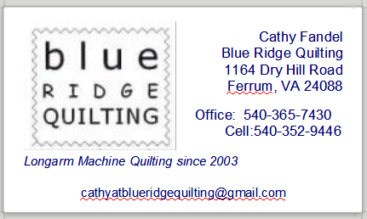
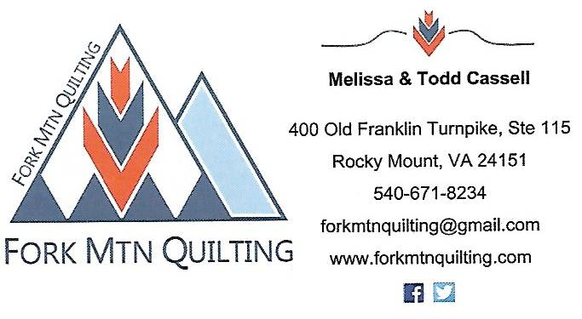

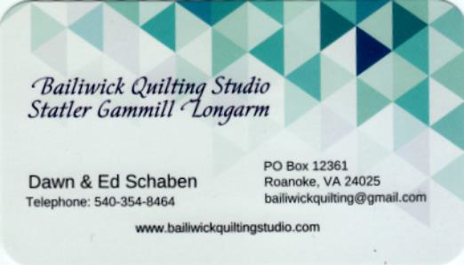
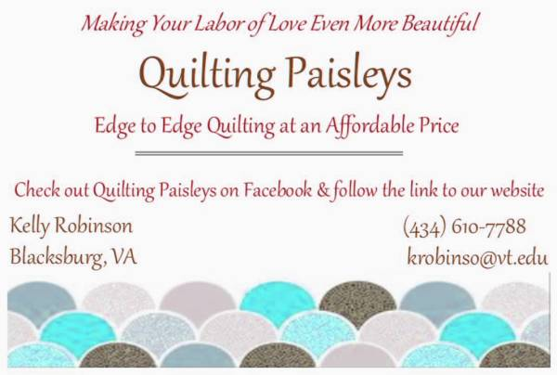


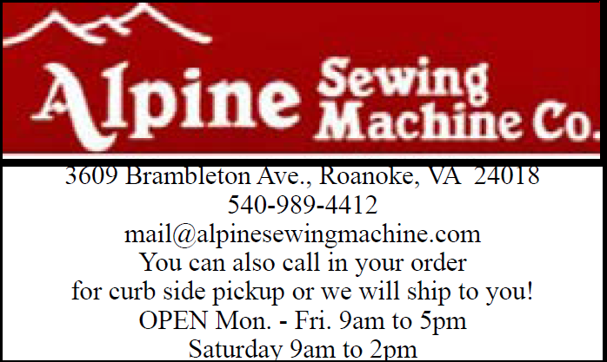

Welcome to a new advertiser, our own Linda Greene, who has restarted her quilting business. Other advertisers should know that it’s time to renew their ads. It’s a bargain -- only $20 for our fiscal year, May 2022-April 2023.
page 13


